TC-CMS-023
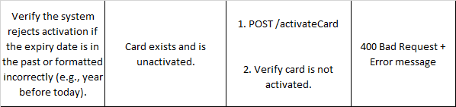
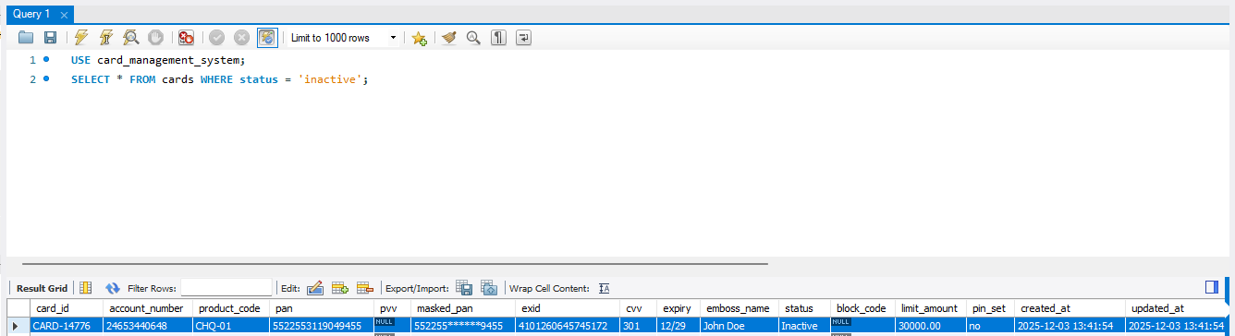
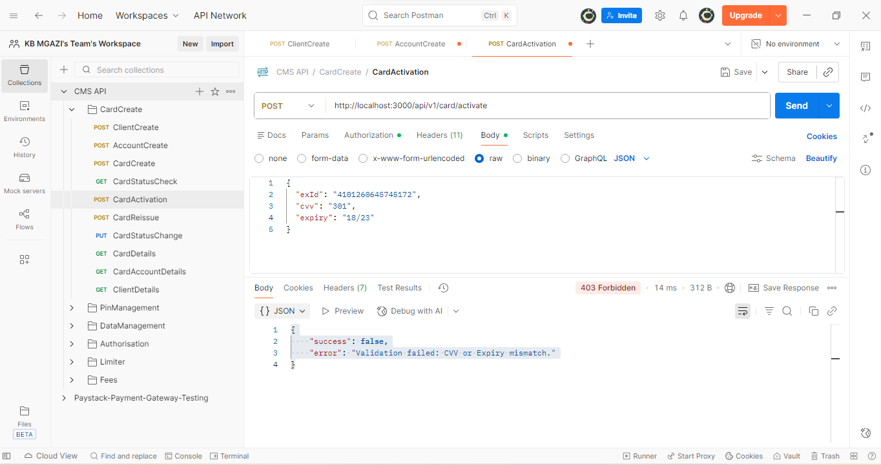
Request:
{
"exId": "4101260645745172",
"cvv": "301",
"expiry": "18/23"
}

Response:
{
"success": false,
"error": "Validation failed: CVV or Expiry mismatch."
}

